**How Green Electronics Can Significantly Reduce Pollution**



As the number of electronic devices on the market grows, so does the amount of electronic garbage, or e-waste. And as more e-waste accumulates in and around our environment, contamination issues such as hazardous substances become more prevalent.

Fortunately, there is an answer: green electronics.

In this article, we will go over:

* What is the difference between e-waste and green electronics?
* The advantages of using green electronics
* How can we make progress toward a greener future?

**What is Electronic Waste (E-Waste)?**

Electronics such as cell phones, laptops, and gaming consoles that are no longer in use and are destroyed are referred to as e-waste.

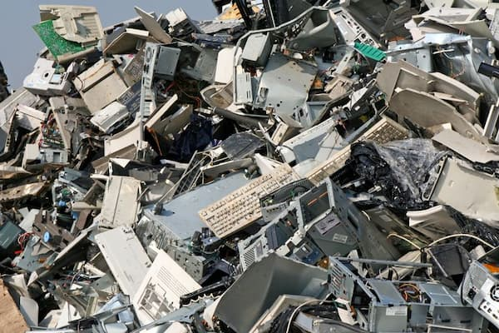

Every year, between 20-50 million metric tonnes of e-waste are generated, with the most of it ending up in landfills in the United States or being transported to landfills in underdeveloped nations.

What is the issue? Landfills are rapidly filling up. Furthermore, incorrect e-waste disposal has a harmful influence on the environment.

The degradation of our air, water, and soil is caused by e-waste that remains in landfills. Worse yet, the standard method for extracting important metals exposes our ecosystem to harmful toxins.

**Common E-Waste Components**

Metal and plastic are the two main types of electronic components.

While most metals may be recycled and reused, many of the polymers used in electronics contain harmful, non-biodegradable elements.

Furthermore, despite the fact that the metal components can be recycled, they frequently wind up in landfills, where they release pollutants into the environment.

So, what can we do to mitigate this potentially dangerous situation? The solution is straightforward: green electronics!

**What are the benefits of using green electronics?**

Green electronics are those that are biodegradable, long-lasting, and recyclable.

We normally think of banana peels or apples when we think of biodegradable; something that breaks down and disappears after a few days. However, no one wants an iPhone that melts in their pocket.

Green electronics, on the other hand, are long-lasting while in use and designed to biodegrade at the end of their useful lives.

**Electronics Made with the Environment Friendliness in Mind**

Green electronics are those that are made using environmentally beneficial methods. They take into consideration energy use as well as carbon output.

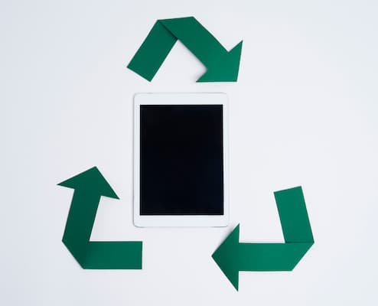

Green gadgets, which are made from recycled materials, help to save natural resources.

So, why should we go green with our electronics?

Green electronics are the way of the future if we want to avoid widespread pollution caused by electrical equipment.

Improper e-waste disposal necessitates the removal of non-biodegradable polymers in order to reach the valuable metals. Acid baths and open-burning are two of the most harmful practises. As a result, chemicals are released into the air, which then infiltrate into our rain clouds.

According to the World Health Organization (WHO), air pollution is responsible for around 4.2 million deaths per year.

1. **Waste Containing Toxic Chemicals**

Electronics contain various hazardous substances that can harm our health.

Among them are the following:

* Lead
* Mercury
* Cadmium
* Arsenic
* Brominated Flame Retardant
* Perfluorooctanoic Acid
* Polyvinyl Chloride
* Thallium

These substances can cause brain damage, respiratory problems, cancer, miscarriages, and other health problems. As a result, you must convert to green gadgets and properly recycle e-waste.

**Green electronics production reduces carbon emissions.**

Switching to green electronics reduces both the quantity of energy utilised and the amount of carbon created.

For example, most precious metals utilised are non-renewable, such as aluminium or iron. Not only are we depleting resources by not reusing metals, but mining these minerals also consumes a significant amount of energy.



Manufacturers might minimise carbon emissions by utilising recycled materials if they began producing green devices.

So, how do we proceed from here?

**Taking Steps Toward a Greener Future**

If we want our children and grandkids to enjoy a healthy and clean future, we can't do much more damage to the earth. It is our duty to leave the planet in a better state than we found it.

So, what steps can you take to make the future greener?

To prevent pollution and eliminate e-waste, environmentalists advocate the following:

* Make a list of your priorities and ask yourself, "Do I Really Need This?" prior to purchasing the most recent electronic advertised
* Take Care Of Your Electronics - Make an effort to extend the life of your electronics by not allowing them to be damaged.
* Invest in the environment – Many companies are starting to make environmentally friendly devices; search for ones that are Energy Star or EPEAT certified.
* Produce Green Electronics - The government is doing everything it can to help you make green electronics, so take advantage of it.
* E-Waste Must Be Recycled Correctly – If you no longer want any devices, recycle them at an environmentally friendly facility.

Any move toward a healthy planet that you can do to decrease e-waste is a step in the right direction.

**Manufacturers are being urged to make environmentally friendly electronics.**

Manufacturers are being encouraged by the government and environmental organisations such as the United States Environmental Protection Agency (EPA) to build cleaner, less hazardous electronics with longer lifespans that are both safe and easy to recycle.

While most manufacturers believe that turning green is good for business, many are unsure how to do it.

However, if the plastics problem is handled, there isn't much else that needs to be done to get e-waste to zero waste. Electronic metals are already highly recyclable, with some metals being more than 95% recyclable.

**Consumers are being urged to take action.**

While the majority of pollution is created by the production of non-sustainable devices, there are still things we can do as consumers to help.

You may contribute to environmental protection by being aware of your electronic habits.

So, while we wait for more manufacturers to start making green electronics, what can you do?

**Recycle Pro will recycle your e-waste.**

Meanwhile, you can help reduce your personal carbon footprint by recycling your devices with Recycle Pro, acting responsibly as a business owner, or volunteering.

Recycling your e-waste with a reputable facility keeps it out of landfills and decreases its negative environmental impact.

[Recycle Pro](https://www.recyclepro.co.uk/) has a solid reputation as a reliable source for e-waste recycling and management. We recycle your old equipment in an ethical and environmentally friendly manner.